Q1. Class with constructor and Getter

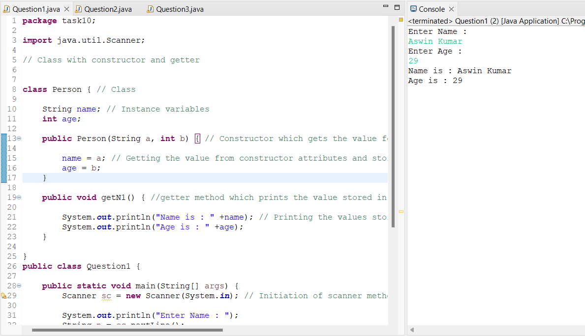

Q1 Output

Q2. Q2. Program for employee salary details and hike

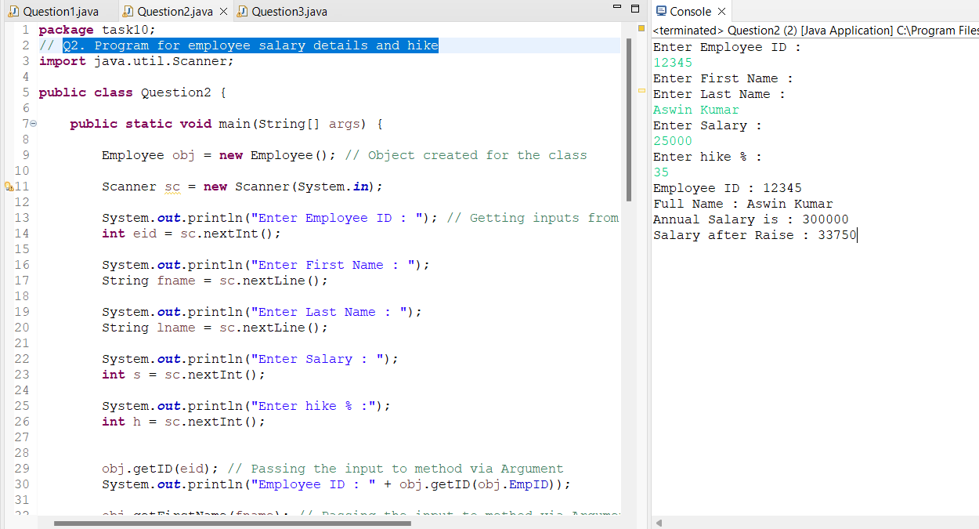

Q2 Output

Q3. Program to calculate circumference of a circle using constructors

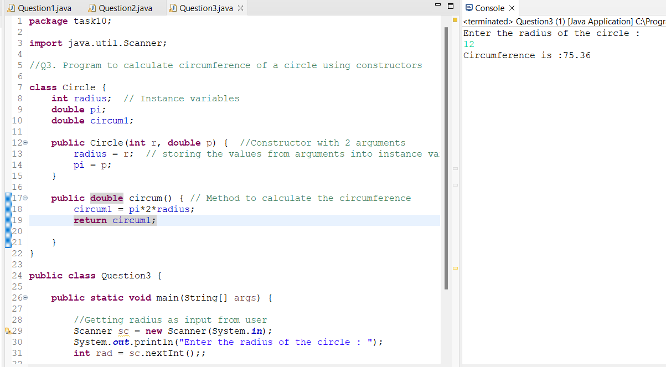

Q3 Output

Q4. Program for Account balance

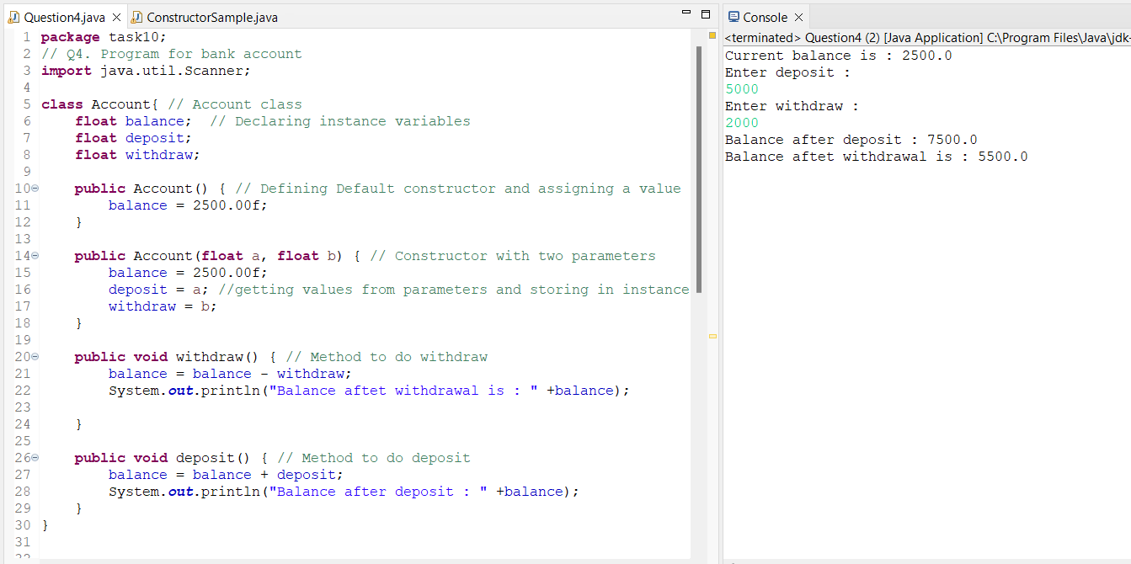

Q4 Output

Q5. Program to create Tea Class

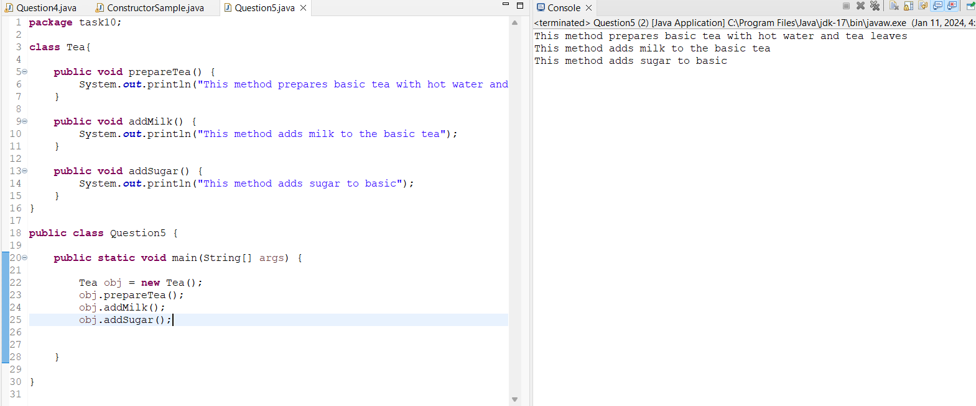

Q5 Output

Q6.